**Problem Statement:** Three missionaries and three cannibals, along with one boat that fits at most two people (and requires at least one person for operation), are on the left bank of a river. The most salient thing about the missionaries and cannibals in the “cohabitation” is that if ever the cannibals in any one spot (left bank, right bank, on the boat) outnumber the missionaries, the outnumbered missionaries will be consumed – eaten! The goal of this problem is to get all six individuals safely across the river from the left bank to the right bank.

**Objects of the World:**  M, C and B. Where M is a missionary, C is a cannibal, and B is a boat.

**Representation of a State of the World:** The world can be represented by one list where ML and MR is a count of the missionaries on the left and right bank respectively. CL and CR is a count of the cannibals on the left and right banks respectively. And B is the location of the boat, being either L or R, meaning left or right bank.

<(ML,MR), (CL,CR), B>

**State Space Description:**

*Initial:* <(3,3), (0,0) L>

*Goal:* {<(0,0), (3,3), L>, <(0,0), (3,3), R>

*Operators:*

**ML** – Empty boat on right and take one missionary back to the left bank

<(ML,MR), (CL,CR), B> | if MR > CR and B=R -￫ <(ML+1,MR-1),(CL,CR), L>

**CL**– Empty boat on right and take one cannibal back to the left bank

<(ML,MR), (CL,CR), B> | if CR <= MR and B=R -￫ <(ML,MR),(CL+1,CR-1), L>

**MR** – Empty boat on left and take one missionary back to the right bank

<(ML,MR), (CL,CR), B> | if ML > CL and B=L -￫ <(ML-1,MR+1),(CL,CR), R>

**CR**– Empty boat on left and take one cannibal back to the right bank

<(ML,MR), (CL,CR), B> | if CR <= MR and B=R -￫ <(ML,MR),(CL-1,CR+1), L>

**MML**- Move two missionaries from the right bank to the left bank

<(ML,MR), (CL,CR), B> | if CR <= MR-2 and B=R -￫ <(ML+2,MR-2),(CL,CR), L>

**MMR**- Move two missionaries from the left bank to the right bank

<(ML,MR), (CL,CR), B> | if CL <= ML-2 and B=L -￫ <(ML-2,MR+2),(CL,CR), R>

**CCL**- Move two cannibals from the right bank to the left bank

<(ML,MR), (CL,CR), B> | if CR-2 <= MR and B=R -￫ <(ML,MR),(CL+2,CR-2), L>

**CCR**- Move two cannibals from the left bank to the right bank

<(ML,MR), (CL,CR), B> | if CL-2 <= ML and B=L -￫ <(ML,MR),(CL-2,CR+2), R>

**MCL**- Move a missionary and a cannibal from the right to the left bank

<(ML,MR), (CL,CR), B> | if CR <= MR-1 and B=R -￫ <(ML+1,MR-1),(CL+1,CR-1), L>

**MCR**- Move a missionary and a cannibal from the left to the right bank

<(ML,MR), (CL,CR), B> | if CL <= ML-1 and B=L -￫ <(ML-1,MR+1),(CL-1,CR+1), R>

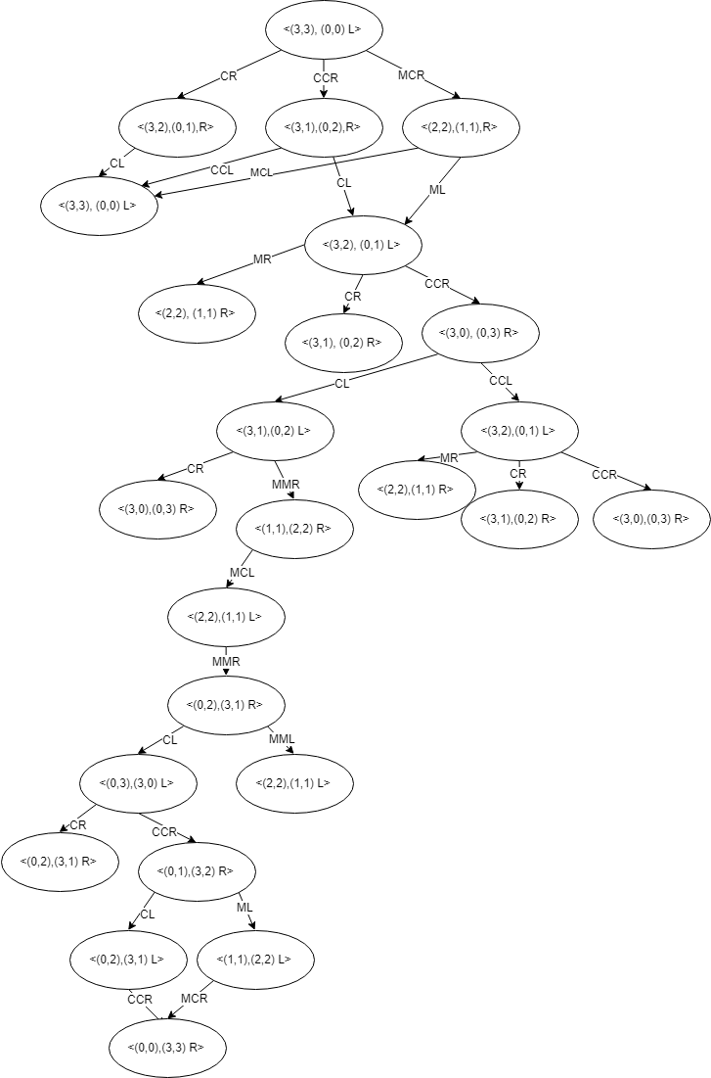**Partial State Space Graph:**

**A State Space Solution:**

{CCR,CL,CCR,CL,MMR,MCL,MMR,CL,CCR,CL,CCR}